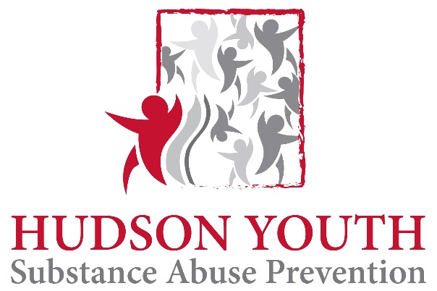

Meeting Agenda
February 2, 2016

- Introductions
- If Only
  - Cheryl Juaire to speak
  - What needs to be done
- In Plain Sight
- SAPC project
- Other community ideas for substance abuse prevention
- Next Meeting
  - March 1, 2016 at 6:30 Hudson Town Hall Auditorium (2nd floor)

