License to Operate Mobile Home Park Permit valid January 1 to December 31 Fee $10

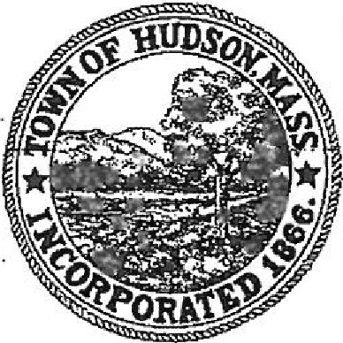
BOARD OF HEALTH
78 Main Street
Hudson, MA 01749
(978) 562-2020

Legal Business Name (Corp., LLC, etc.) _________________________________________________________

DBA (if different) __________________________________________________________________________

Office Address _________________________________________________________________________________

Mailing Address (if different) ______________________________________________________________________

Parcel ID# (Please obtain from the Assessor's Office) ______________________________________________

Business Phone Corporate Phone ____________________________
Owner/President Name ___________________________________________________________________________
Manager/Agent/Operator Name ________________________________________________________________
# of all Units (all occupied/unoccupied units)
Is Development Complete? Yes No
If development is not complete, provide total # of completed units ___________________________

Pest Control Manager (Include Pest Control Contract) __________________________________________________
Trash/Garbage Collector & Schedule ____________________________________________________________

On Site Club House Name ___________________________________________ Capacity _________________

Water Source:
Sewer Source ________ Overnight Camp
Cert. of Occupancy Issue Date _____
Email _______________________________

Name and Title: (Please print) Signature:

FOR OFFICE USE ONLY:

Munis Number: ___________

Access: ________

W/C Rcvd: ________

Liability Rcvd:________

Revised 2022

